RAILWAY RESERVATION PROJECT

**2**

**A**

**PROJECT REPORT ON**

**RAILWAY RESERVATION**

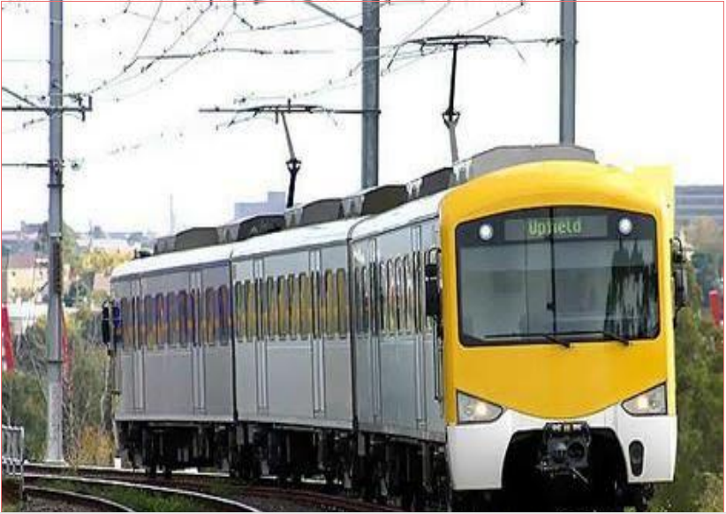

**PREPARED BY:-**

**Vikas R Mandape**

RAILWAY RESERVATION

**1) Preface**

**2) Acknowledgement**

**3) project Profile**

**Title**

**Documentation Tools**

**Project Duration**

**Project Team Size**

**Project Guide**

**Develop By**

**Submitted To**

**4) Introduction**

**5) Project Summary**

**6) System Requirement**

**7) Technology Study**

**8) Analysis**

** Requirement**

**System Analysis**

** Feasibility Analysis**

**9) Design**

☞

1. **Data flow Diagram**

**11) ER-Diagram**

**12) Screen Shots**

**1) Project Risk**

**2) Conclusion**

**3) Bibliography**

**PREFACE**

**I am pleased to submit this report on the project developed at Pillai’s College as a part of 5th semester curriculums.**

**Once you login to the system, you can use all the facilities**

**provided by this windows application. It reduces the complexity of user**

**to use such system like forum. The user can also use other facilities of**

**this site is search engine.**

**This project report contains overview of the project. The person**

**with technical knowledge about web development can easily understand**

**the contents of this project.**

**Whole implementation of this site is shown with figures, Data**

**Flow Diagrams, Databases and screen shots. That’s why; it is very easy**

**to understand for any person.**

**ACKNOWLEDGEMENT**

As per the schedule of the course of B.S.C (comp science), The project work is must for each and every student in different government organization or private organization. During development period, the student has to develop software and implement it successfully.We are the student of B.C.A (Shree M & N Virani Science College, Rajkot) is affiliated with Saurashtra University. It is a matter of great pleasure for us to this opportunity expressing our sincere sense of gratitude to Mr. Pardip Vanpariya & Mr. Keyurzala for giving us precious guidance, inspiration and great support throughout the project development. We are especially thankful to him for their kind co-operation.

We are thankful to respected Mr. A.U.Patel (Principal of Shree M & N Virani Science College, Rajkot) for giving us opportunity to do this project. His Inspiration and generous support gave us sufficient strength to prepare the project.We are also thankful to respected Mr. Hitendra Donga & Stavan Patel (H.O.D of Computer Department) whose energetic support, guidance and inspiration gave us a vast path to the success of this project.

Only the expression of “Thanks” can’t appreciate these wonderful

and kindly natured persons who contributed their best efforts to help us.

Thank You to all of you with honors.

Yours faithfully,

Vikas mandape

(Final Year Computer Science)

**PROJECT PROFILE**

**PROJECT TITLE :-**

**➢ Railway Reservation**

**HARDWARE AND SOFTWARE USED :**

**Software Requirement :-**

**➢ Operating System :- Windows 8**

**➢ Front end :- HTML,php➢ Back end :- MySql**

**Hardware Requirements :-**

**➢ RAM :- 412 MB or more**

**➢ Hard disk :- 10 GB or more**

**DOCUMENTATION TOOLS :-**

**➢ Microsoft word 2007**

**PROJECT DURATION:**

**➢ 4 MONTHS**

**SEM – YEAR :**

**5th SEM –2012**

**PROJECT GUIDE:**

**➢ Abhijit sir**

**DEVELOPED BY:**

**➢ vikas mandape**

☞

**PRELIMINARY**

**INVESTIGATION**

RAILWAY RESERVATION

**2012**

**Introduction**

**This project will give us the information about railway reservation .**

**This system is basically concerned with the reservation and**

**cancellation of railway tickets to the passengers. To be more specific,**

**our system is limited in such a way that a**

**train starting from a particular source will have a single destination .**

**The basic functions being performed by our system are reservation and**

**cancellation.**

**Customers can find the proper and correct information about the railway**

**and shows the**

**It reserves and cancels seats for the passenger.**

**It contains information about the trains.**

**It contains information about the Seat Availability**

**Railway time table**

**Reservation Possibilities.**

**Train Ticket booking**

**Booked Railway Ticket Status,**

**Train between stations**

**Feasibility Study:**

**1) Technical Feasibility: It is an evaluation of the hardware and software and**

**how it meets the need of the proposed system.**

**It is possible to develop the system by using PHP as front end tool and**

**MySQL as back end tool it will be helpful for the Computer Institute. Admin,**

**Teacher and the Students can use it without any specific training.**

**2) Economical Feasibility: It deals with the analysis of a project's costs and**

**revenues in an effort to determine whether or not it is logical and possible to**

**complete.**

**The Website will help in automating the offline manual processes leading to**

**profits and gains for the Institute. With this website the machine and manpower**

**utilization are expected to go up. This will save the time. It will benefit the**

**Institute.**

**3) Financial Feasibility: It is an analysis of the marketplace to determine if it is**

**economically practical and desirable to develop a particular project.**

**The total cost of project is estimated. It is financially feasible for a fullyfledged institution like PCACS to afford software which will impart**

**Page | 10 Name: Gulnaz Begam**

**Class: TY BSc. CS – ‘A’**

**Student Information Management System**

**innumerable profits to the institute in future. In long term, it will prove out to be**

**a fruitful investment.**

**4) Operational Feasibility: Operational feasibility is the measure of how well a**

**proposed system solves the problems, and takes advantage of the opportunities**

**identified during scope definition and how it satisfies the requirements**

**identified in the requirements analysis phase of system development.**

**The system will be able to satisfy the needs of the students as they just need**

**to connect to internet to access these online services. Students will also be able**

**to get online Bonafide certificate which they need to get signed by the principal.**

**Their grievances will be looked upon online by the management. Thus, the**

**paper based work has greatly been reduced**

**Stakeholders:**

**1. Admin: There will be a person who will have access to all the data given by**

**the users, who will filter the data, provide the genuine information to the users.**

**Such a person is called administrator or admin.**

**2)Faculty Members: Faculty member are also responsible for providing all**

**that information which is essential to the student on a particular course. They**

**will directly interact with the system.**

**4. Developers: We selected developers as stakeholder because they develop this**

**system and Work for further development. If occurs any system interruption,**

**they will find the problem and try to solve it.**

**5. Alumni: Alumni’s will also interact with the system. They provide**

**information in the system and also are provided with the system.**

**6. Guest: They indirectly interact with the system through an interface to get**

**information that is essential to them.**

RAILWAY RESERVATION

**Technology Study**

**Introduction to PHP:**

# **✓**Introduction to PHP

PHP is one of the most widely used server side scripting language for web development. Popular websites like Facebook, Yahoo, Wikipedia etc, and our very own Studytonight, are developed using PHP.

PHP is so popular because it's very simple to learn, code and deploy on server, hence it has been the first choice for beginners since decades.

In this tutorial series we will be covering all the important concepts of Php language from basics to advanced and will also share some ready-to-use, useful code sinppets for beginners to kickstart their web development project.

## What is PHP?

PHP stands for **Hypertext Pre-Processor**. PHP is a scripting language used to develop static and dynamic webpages and web applications. Here are a few important things you must know about PHP:

1. PHP is an Interpreted language, hence it doesn't need a compiler.
2. To run and execute PHP code, we need a Web server on which PHP must be installed.
3. PHP is a server side scripting language, which means that PHP is executed on the server and the result is sent to the browser in plain HTML.
4. PHP is open source and free.

**Php:**

**PHP (recursive acronym for PHP: Hypertext Preprocessor) is a** widely-used open

source general-purpose scripting language that is especially suited for web

development and can be embedded into HTML.

**Following tasks are possible with Php:**

• PHP can generate dynamic page content

• PHP can create, open, read, write, delete, and close files on the server

• PHP can collect form data

• PHP can send and receive cookies

• PHP can add, delete, modify data in your database

• PHP can be used to control user-access

• PHP can encrypt data

With PHP you are not limited to output HTML. You can output images, PDF files,

and even flash movies. You can also output any text, such as XHTML and XML.

Advantages of Php are:

• PHP runs on various platforms (Windows, Linux, Unix, Mac OS X, etc.)

• PHP is compatible with almost all servers used today (Apache, IIS, etc.)

• PHP supports a wide range of databases

**•** PHP is free. Download it from the official PHP resource: **[www.php.net](http://www.php.net)**

**PHP is easy to learn and runs efficiently on the server side**

## **Features of PHP :-**

The main features of php is; it is open source scripting language so you can free download this and use. PHP is a server site scripting language. It is open source scripting language. It is widely used all over the world. It is faster than other scripting language. Some important features of php are given below;

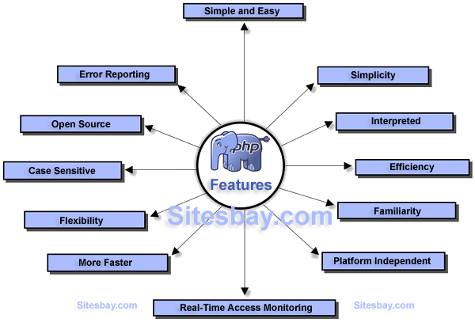

**It is most popular and frequently used world wide scripting language, the main reason of popularity is; It is open source and very simple.**

* **Simple**
* **Faster**
* **Interpreted**
* **Open Source**
* **Case Sensitive**
* **Simplicity**
* **Efficiency**
* **Platform Independent**
* **Security**
* **Flexibility**
* **Familiarity**
* **Error Reporting**
* **Loosely Typed Language**
* **Real-Time Access Monitoring**

### Simple

It is very simple and easy to use, compare to other scripting language it is very simple and easy, this is widely used all over the world.

### Interpreted

It is an interpreted language, i.e. there is no need for compilation.

### Faster

It is faster than other scripting language e.g. asp and jsp.

### Open Source

Open source means you no need to pay for use php, you can free download and use.

### Platform Independent

PHP code will be run on every platform, Linux, Unix, Mac OS X, Windows.

**2012**

**MySQL Server**

MySQL Server is a high specification database management system

that replaces SQL Server 2005. In addition to the original version, SQL

Server 2008R and 2008R2 are available with a simple upgrade.

According to Microsoft's brochure the SQL Server 2008 can "manage

any data, any time, any place." With such a strong mission statement the

softwtare system is at the pinnacle of modern and integrative data

management.

**MySQL Server Features**

➢ Search and query functions are faster by a feature that reduces

storage space through data compression.

➢ Security is paramount with a new data encryption application as

well as a policy management feature that ensures compliance

across the network

➢ Performance System Analysis is another feature enabling a system

wide troubleshoot for specific criteria or problems within the

database. Finally, continuity for applications and hardware

upgrades provide a seamless platform for growth.

**System Analysis**

**➢** We have gathered all information by visiting a main office and

analyze the working of the government railway reservation system.

How they maintain details of passengers.

➢ Today all reservation systems in real time are computerized. All

transactions of railway reservation can be done through software

related to railway reservation.

➢ Today user wants to do transactions fastly so they can use software

or system for store information access the information. So we have

developed such a software, they can help them.

➢ According to analysis of many sites and reservation system we put

all the facilities that can help the users to get reservation

➢ Facilities like reservation, cancellation of tickets, get the distance

between cities and etc.

**2012**

**FACT FINDING TECHNIQUES**

**1. Onsite Observation’s**

**Observations were done during the first interview with Principal. It was very**

**useful in which it helped us to understand how each employee of college works**

**and interact with the current system.**

**2. Review the existing documents:**

**Various types of document were collected. These documents include**

**admission forms, fee receipts, Bonafide certificates, etc.**

3. Interviews:

**We mainly interviewed the admission cell employees and the office**

**personnel.**

**The information provided by both interviewees was very important because it**

**helped us in the analysis of the current system and the constructs of the data flow**

**diagrams. In the interview some objectives are considered such as;**

**Feasibility**

The feasibility study is the important step in any system development

process. Because it makes analysis of different aspects like cost

required for developing and executing the system, the time required

for each stage of the system.

If these important factors are not analyzed then definitely it would

be a total failure. So for running the application and the organization

successfully this step is a very important step in a software

development lifecycle process.

**There are three types of feasibility analysis:**

1) Operational feasibility

2) Technical feasibility

3) Economical/financial feasibility

**1) Operational Feasibility:-**

**•** Operational feasibility measures how well the solution will work in the organization and how will end-user &management feels about the system. Proposed system is helpful for all the users associated with the organization.

• It will allow the administrator to have up-to-date information regarding all the aspects of their users, the decision-making process will also become faster with the **2**use of data integration, consolidation. So it is feasible to implement the system.

**2) Technical feasibility:-**

**•** This involves questions such as whether the technology needed for the system exists, how difficult it will be to build, and whether the firm has enough experience using that technology.

• This system required minimum hardware equipment to run efficiently.

**3) Economical feasibility:-**

**•** Economically to find out whether this project is economically feasible or not for that used feasibility

analyses.

• In this stage list direct costs or indirect costs associated with the project.

**2012**

**User Requirements**

**➢** To do the reservation transaction user must have the unique user name and password.Users should be able to view a train detail according to their requirements.

➢ For reservation booking user has to fill all the information that is given in the form.

User can cancel the reservation by giving the unique passenger id and other necessary details.

➢User can get the distance between two cities by giving the name of cities.

**Data flow Diagram**

**➢ Definition:**

Data-Flow design is concerned with designing a sequence of functional

transformations that converts system inputs into the required outputs.

Data-flow diagrams are useful and intuitive way of describing a system.

They are normally understandable without special training, especially if

control information is excluded.

Conventions used in drawing the data-flow diagram, here are given as

below:

Data Storage

Data Flow

Process

Entity

**Data flow Diagram**

**➢ Definition:**

Data-Flow design is concerned with designing a sequence of functional

transformations that converts system inputs into the required outputs.

Data-flow diagrams are useful and intuitive way of describing a system.

They are normally understandable without special training, especially if

control information is excluded.

Conventions used in drawing the data-flow diagram, here are given as

below:

**2012**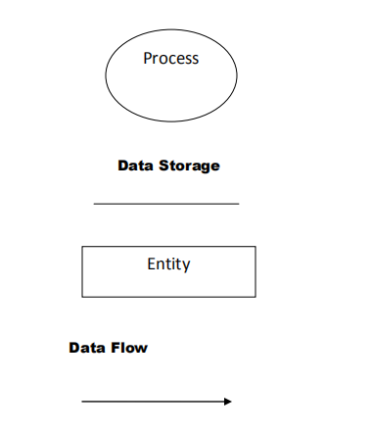

**Data Flow Diagram**

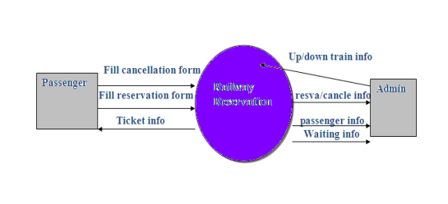

**E – R Diagram**

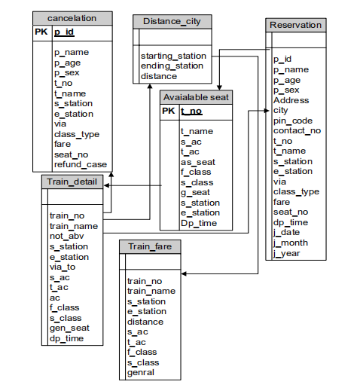

**ActivityDiagram**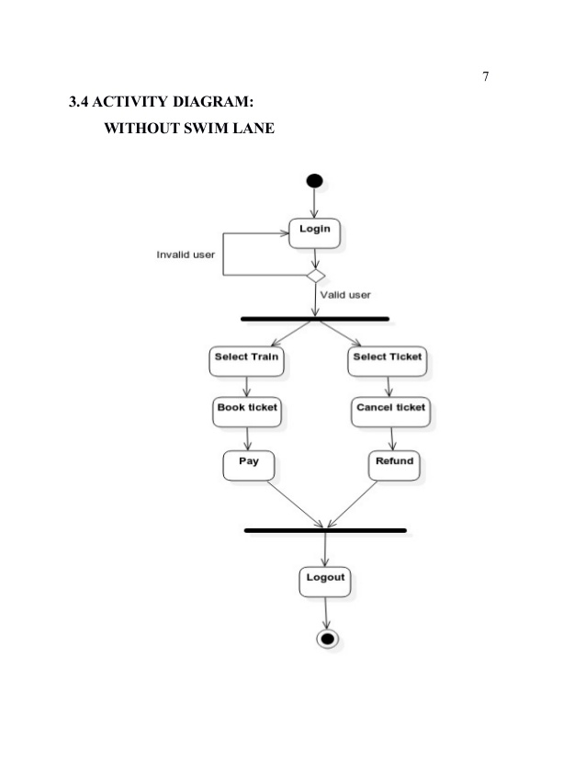

**Gantt chart/Sequence Diagram**

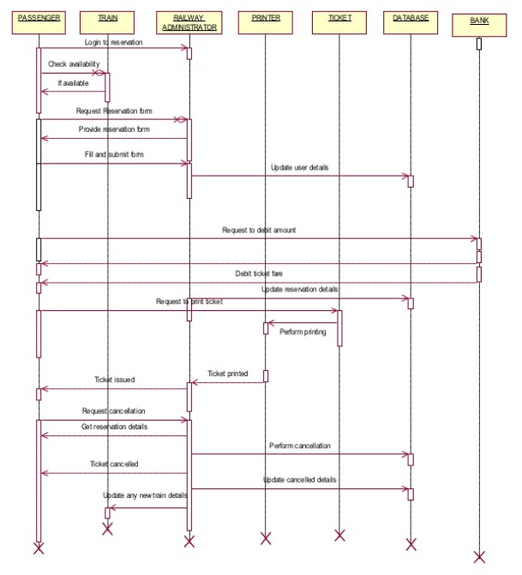

**class Diagram**

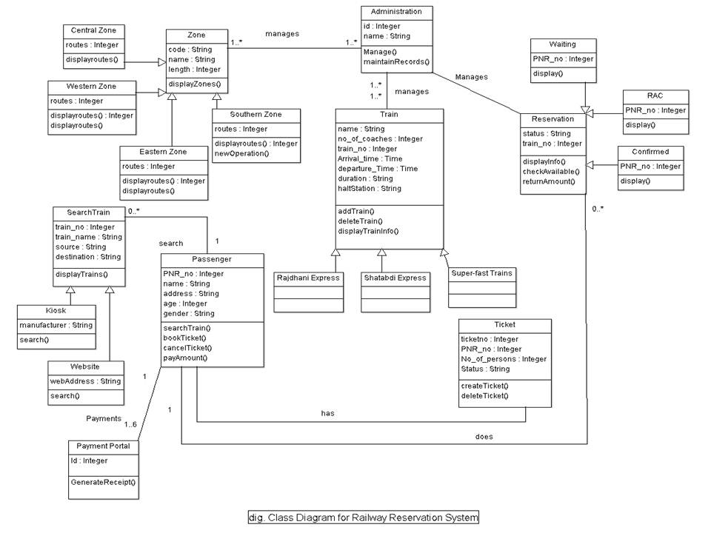

**Booking table:-**

**Table name :- booked_passenger**

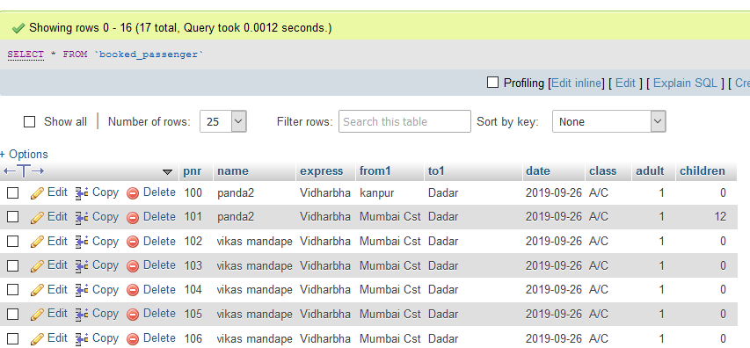

**Feedback :-**

**Table name :- feedback**

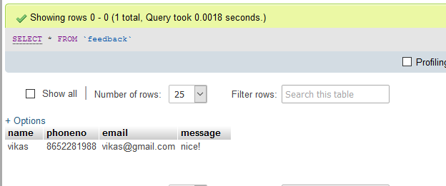

**Register user**

**Table name :- register**

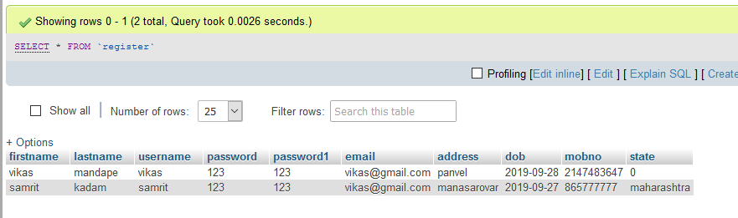

**You have to give card number and cvv while booking a ticket**

**Credit card table**

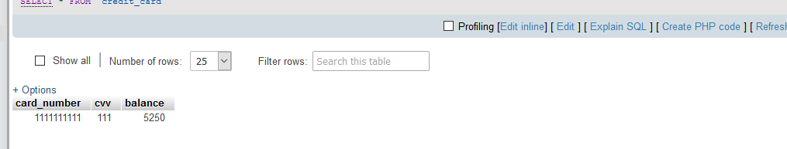

**Project Risk**

**➢ Project Risks threaten the project plan that is, if project risk become real are**

**likely project schedule will slip and that costs will increase.**

**➢ Project risk identify potential budgetary, schedule, personal, resource and**

**requirement problems and their impact on a software project.**

**➢ Project complexity, size and degree of structural uncertainly where also defined**

**as project risk factor.**

**➢ We have distributed the possible risk the following categories and tried to find out the possible risk categories:-**

**1. Size-related risks: Risk related with the size of the project**

**2 . Process definition: Risk associated with the degree to**

**which I have defined my software installation process.**

**3 . Development environment risk: Risk associated with the**

**availability and quality of the tools to be used to build the**

**product.**

**4. Technology risk: Technology availability and usability.**

**5. Experience: Available experience in me concerned technology.** **2012**

**2012**

**Screenshorts**

**Home screen**

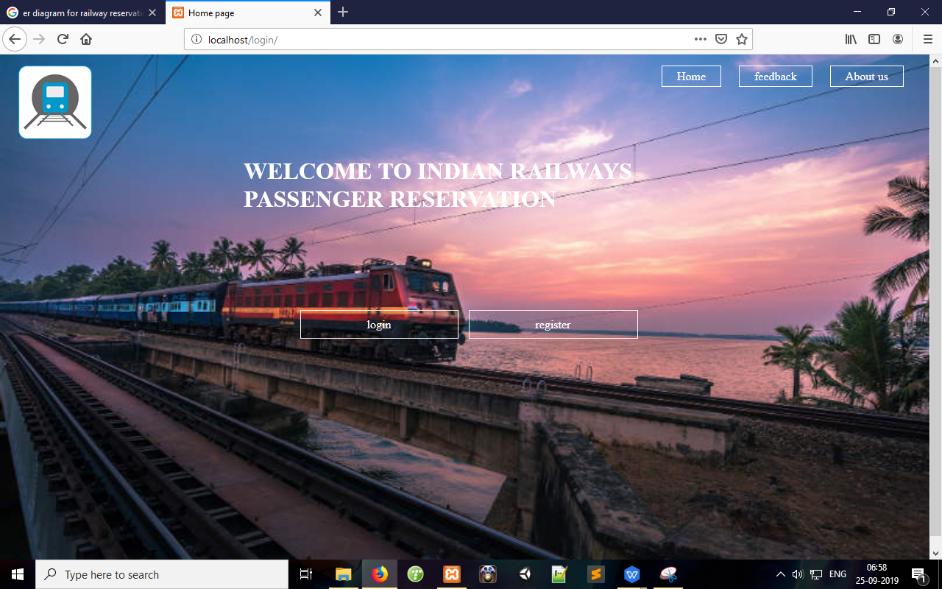

**Register page**

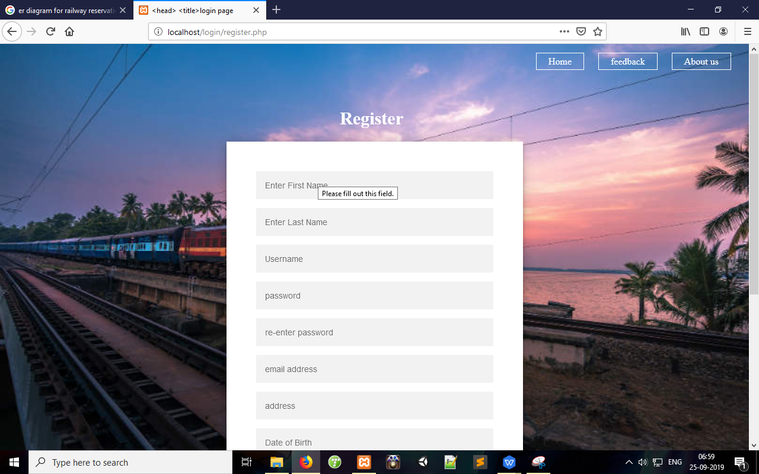

**Login page**

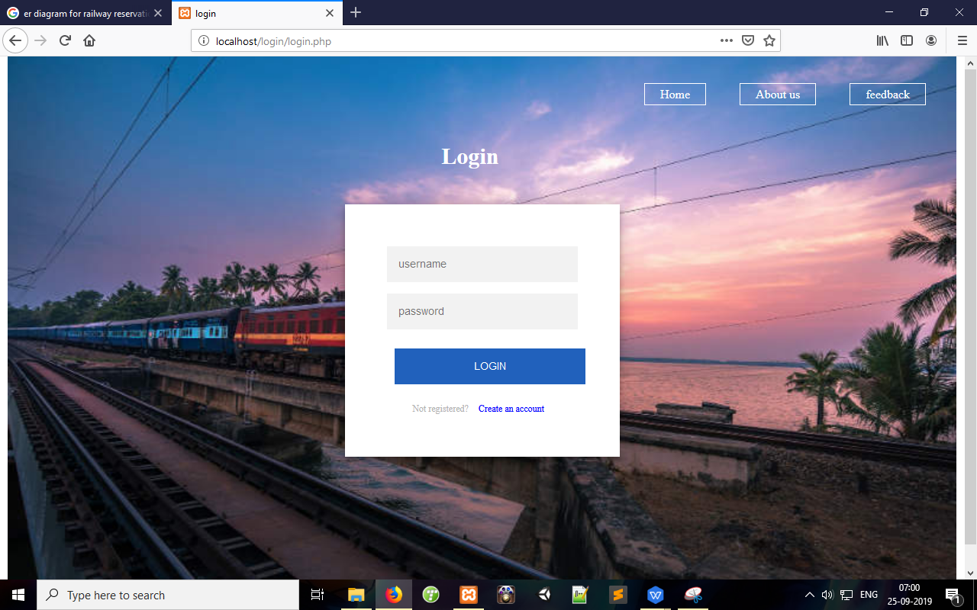

**Feedback page**

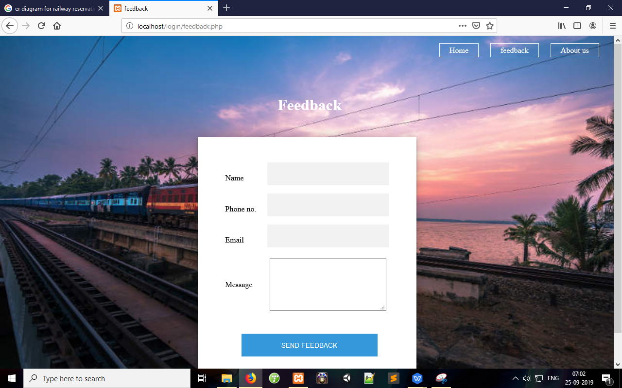

**About us page**

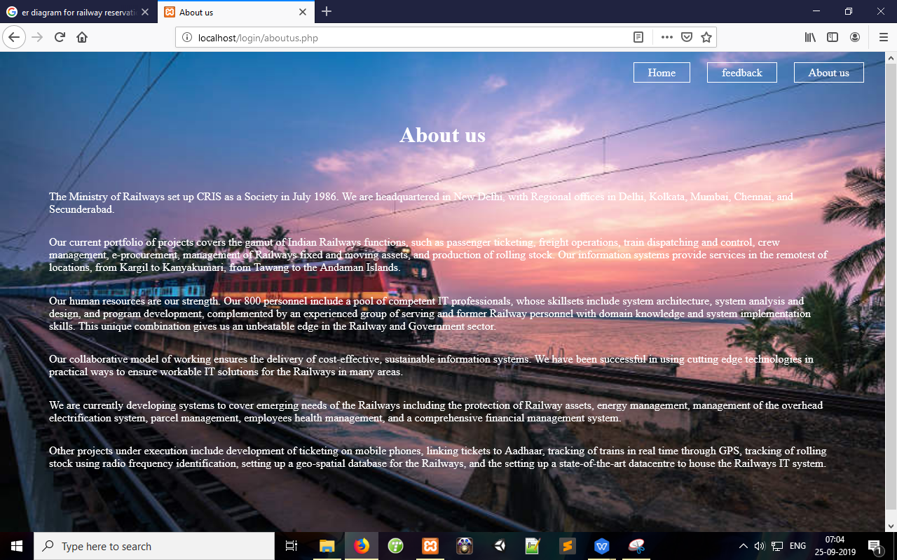

**User home screen**

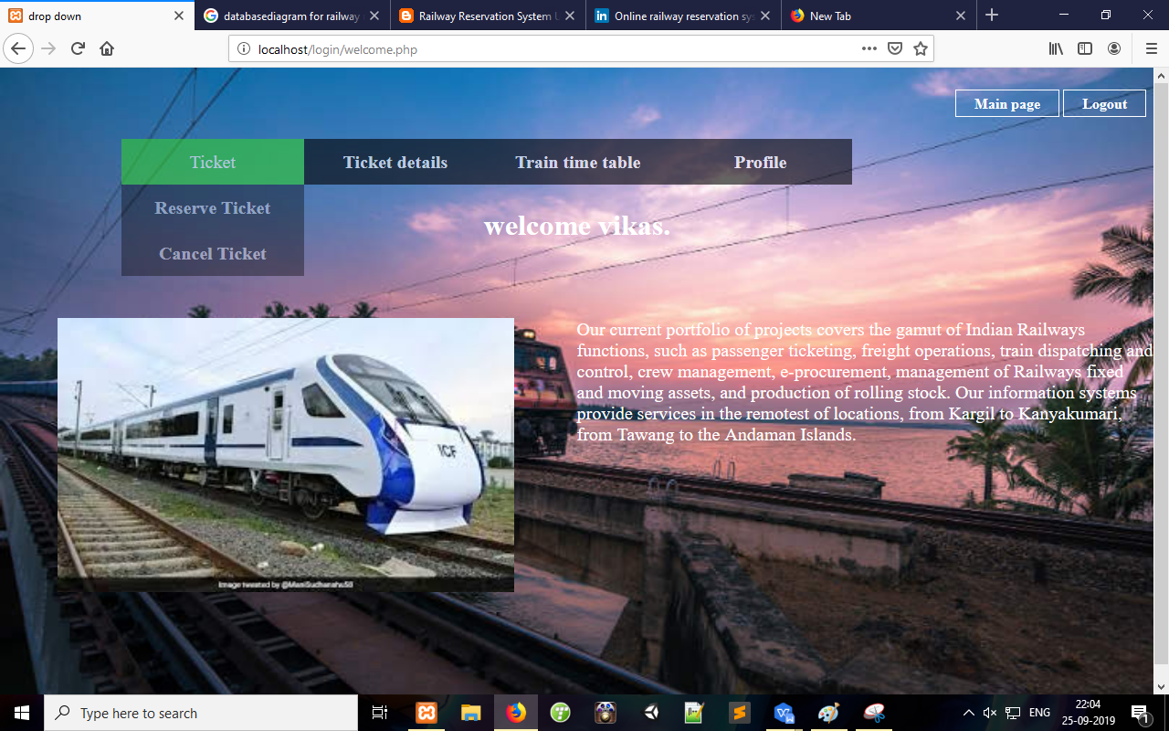

**Ticket Booking page**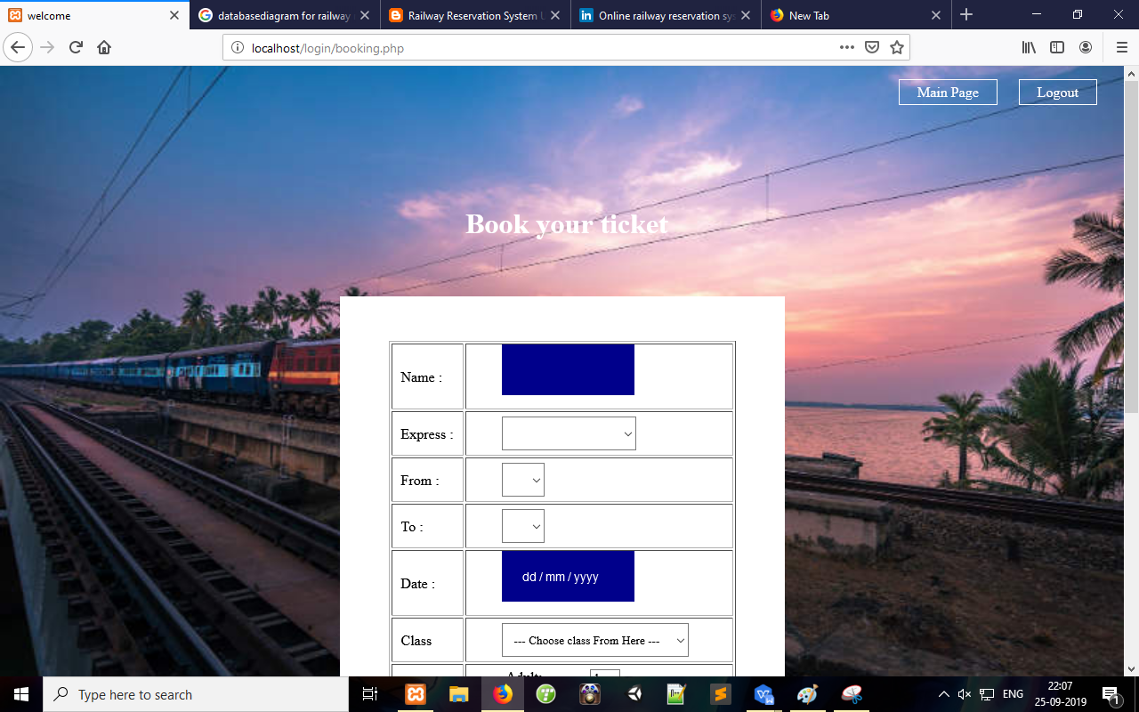

Ticket cancel page

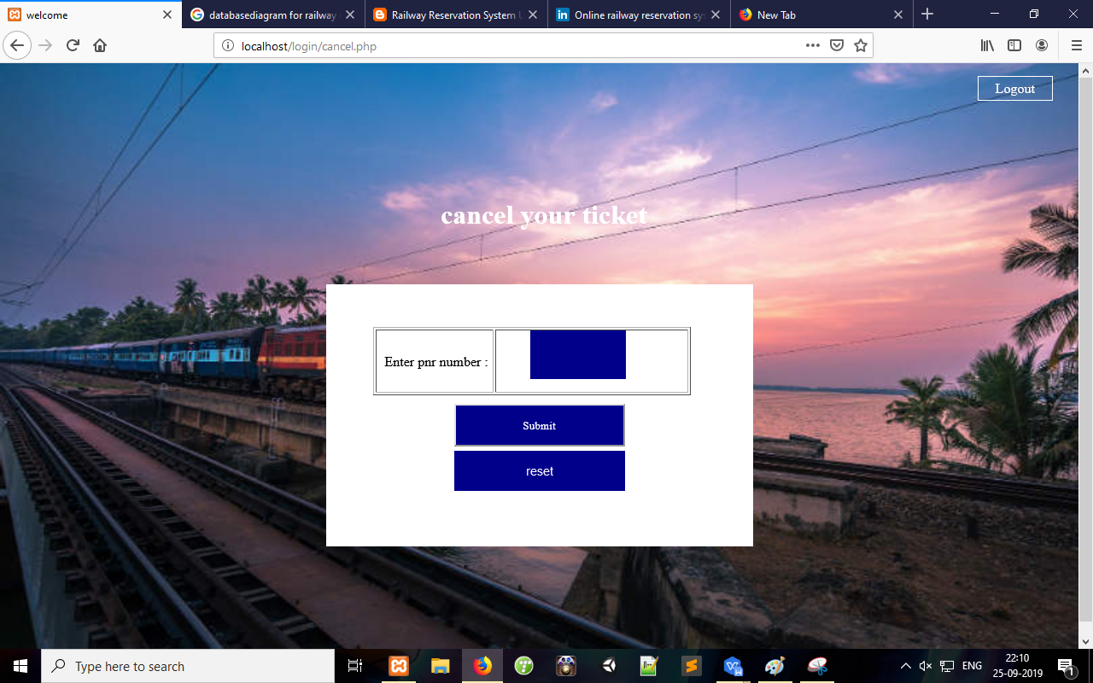

**Ticket detail page**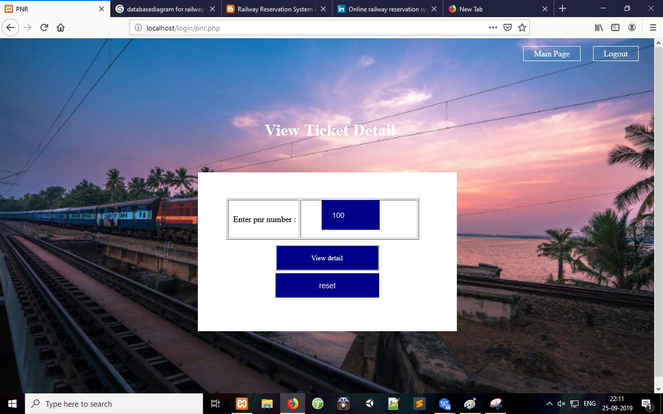

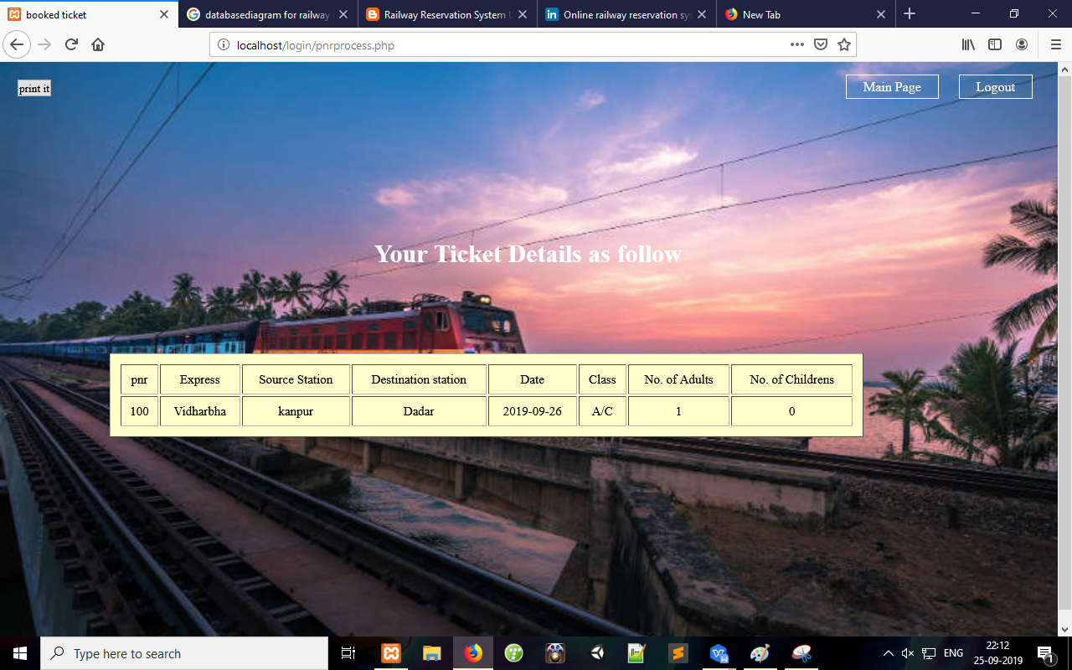

**Train time table page**

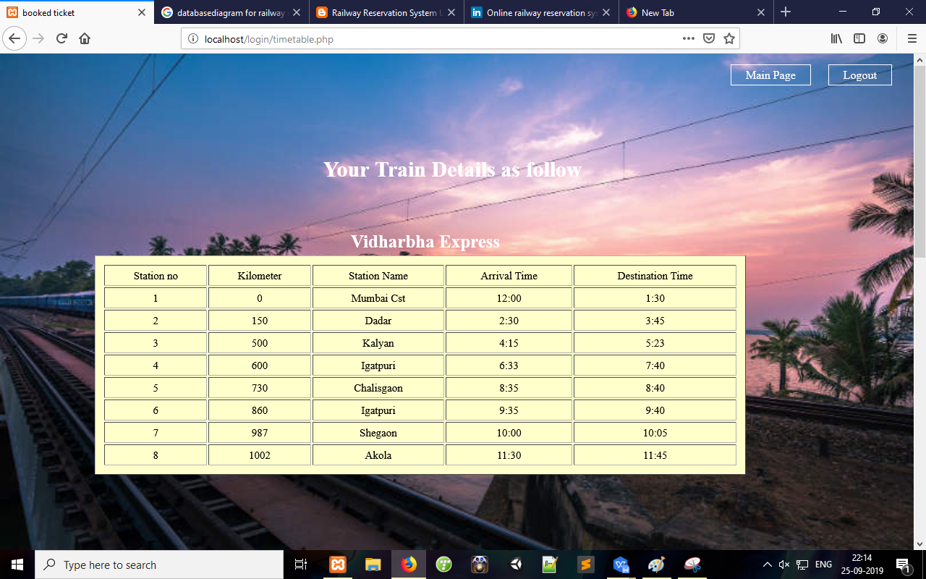

**User Profile page**

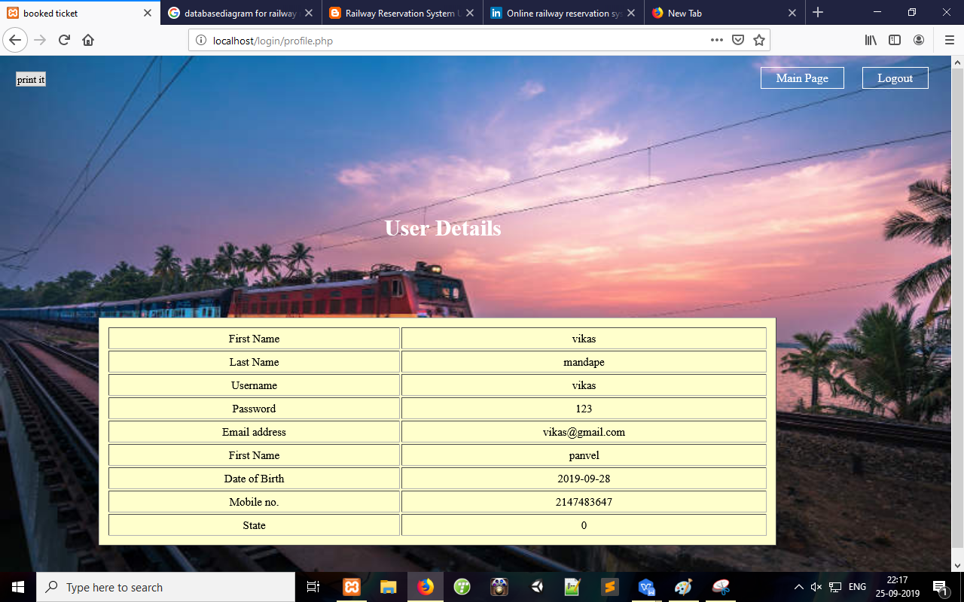

**Admin page**

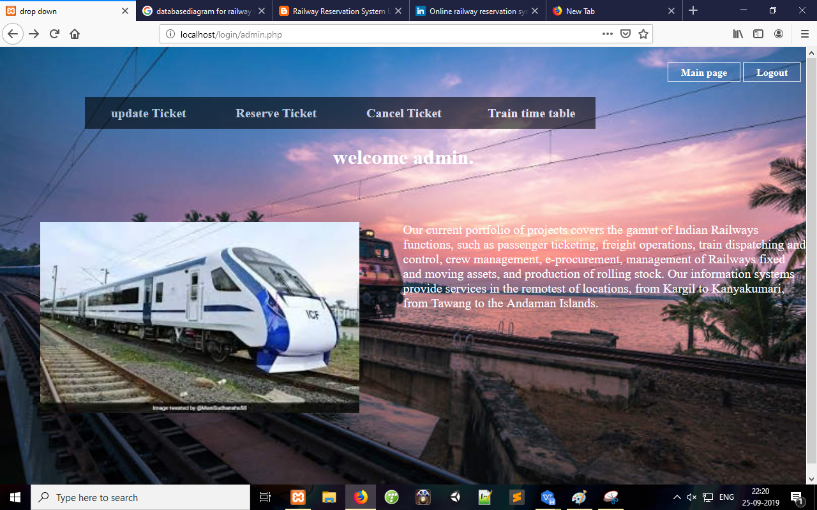

**Admin updating ticket page**

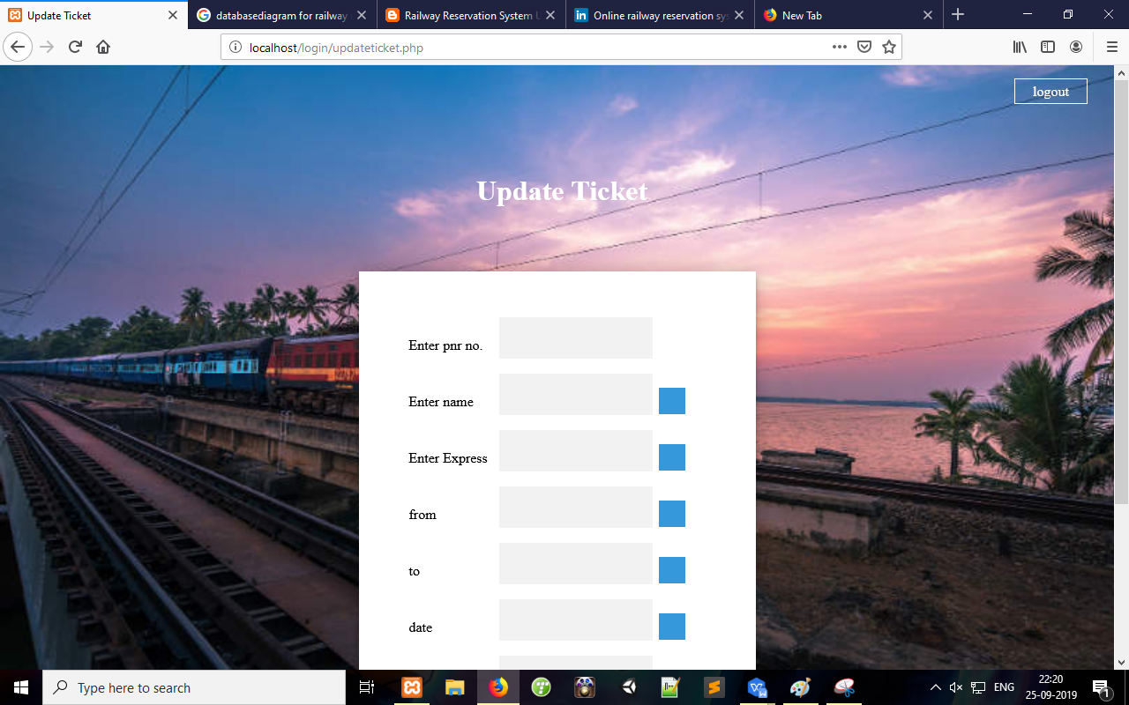

**Admin canceling ticket**

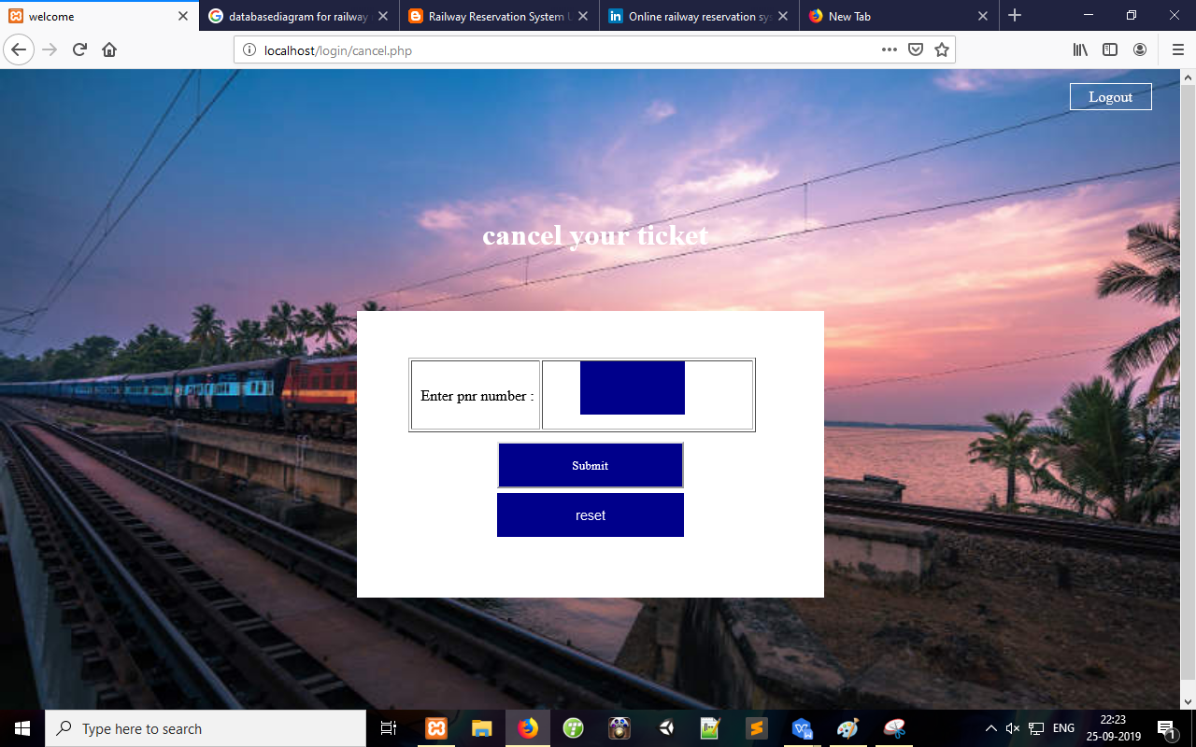

**Project Risk**

**➢ Project Risks threaten the project plan that is, if project risk become real are**

**likely project schedule will slip and that costs will increase.**

**➢ Project risk identify potential budgetary, schedule, personal, resource and**

**requirement problems and their impact on a software project.**

**➢ Project complexity, size and degree of structural uncertainly where also defined**

**as project risk factor.**

**➢ We have distributed the possible risk the following categories and tried to find**

**out the possible risk categories:-**

**1. Size-related risks: Risk related with the size of the project**

**2 . Process definition: Risk associated with the degree to**

which I have defined my software installation process.

**3 . Development environment risk: Risk associated with the**

availability and quality of the tools to be used to build the product.

**4. Technology risk: Technology availability and usability.**

**5. Experience: Available experience in me concerned technolo**

**Conclusion**

Practical Training is a very important part of the curriculum as it

strengthens the concepts and enhances knowledge about the practical

implementation of all the theory concepts, we have learn so far in

different subjects.

Our project is railway reservation system. This project is used to keep a

track on reserving the seat to the passenger. It helps managing the

system very efficiently and conveniently.

Although the project work has been done in a complete and detailed

manner but due to the constraint of time, we could not include some

more features we wanted to. We left these features as a part of the

feature development. As soon as we’ll get time we’ll try to add them to

my project.